Holland Park’s Cup of Tea

Talk on Thursday, 25 October, at 7pm in The Orangery
Holland Park has a long history of growing glorious camellias. Some, thought to have been planted around 1890, are still resplendent right next to The Orangery. What the Park has not had until this June is the Camellia sinensis, which is of course the plant that produces tea.
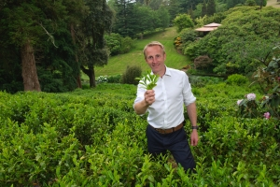
Our speaker, Jonathan Jones, knows all about camellias because he established the first British tea plantation at the Tregothnan Estate in Cornwall. The estate is owned by the Boscawen family, who have a passion for growing rare plants, and Jonathan joined them as head gardener just over 20 years ago. Since being granted a Nuffield Scholarship to develop the tea plantation, he has travelled to all the major tea-producing countries in search of success stories. Tregothnan is now a very successful tea business itself.
Drinking tea is part of the British identity but how much do we really think about what goes into making the perfect brew, from growing the plants, harvesting and processing the leaves, to making the perfect beverage. Having attended a day-long tutorial by Jonathan, I know that he is a fascinating speaker, with an impressive knowledge of his subject. We are fortunate to catch him between his travels to come and share his experience with us.
Tickets are £18, to include Janice Miles’ delicious canapés, wine, and we might even get a tea cocktail!
Jennie Kettlewell
Photo courtesy of Tregothnan Estate
[July 2018]

